Q1.Write a program to print hello world?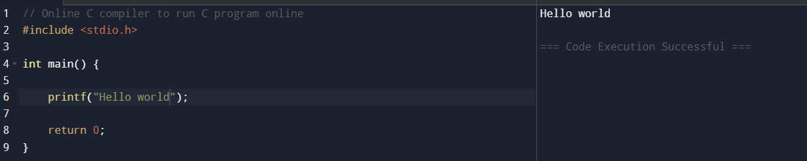

Q2.Write a program to print your basic information?

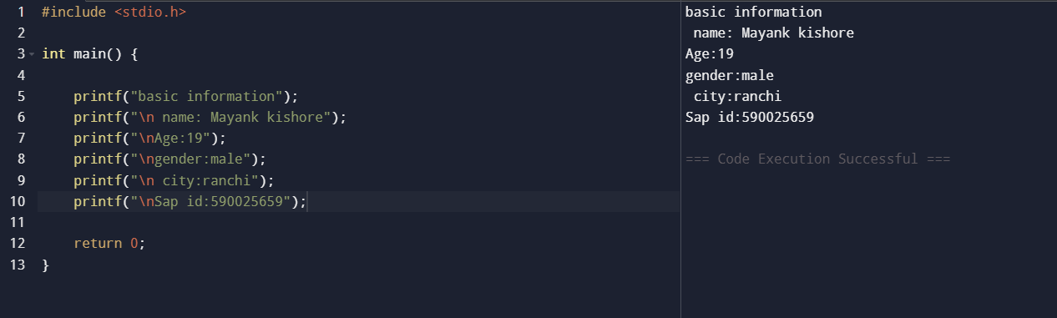

Q3.Design a simple calculator?

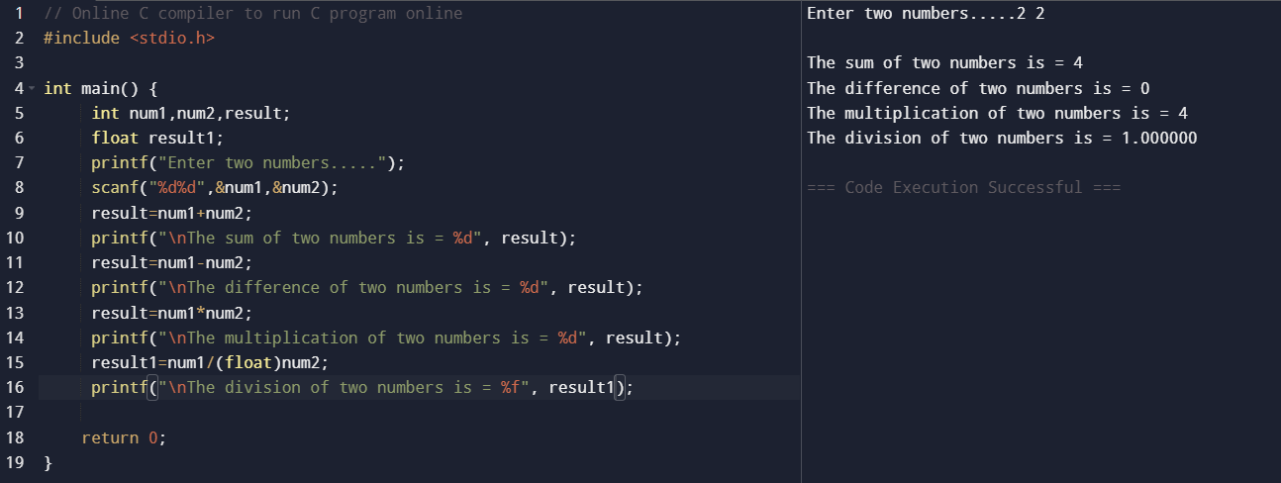

Q4.Write a program to print simple interest?

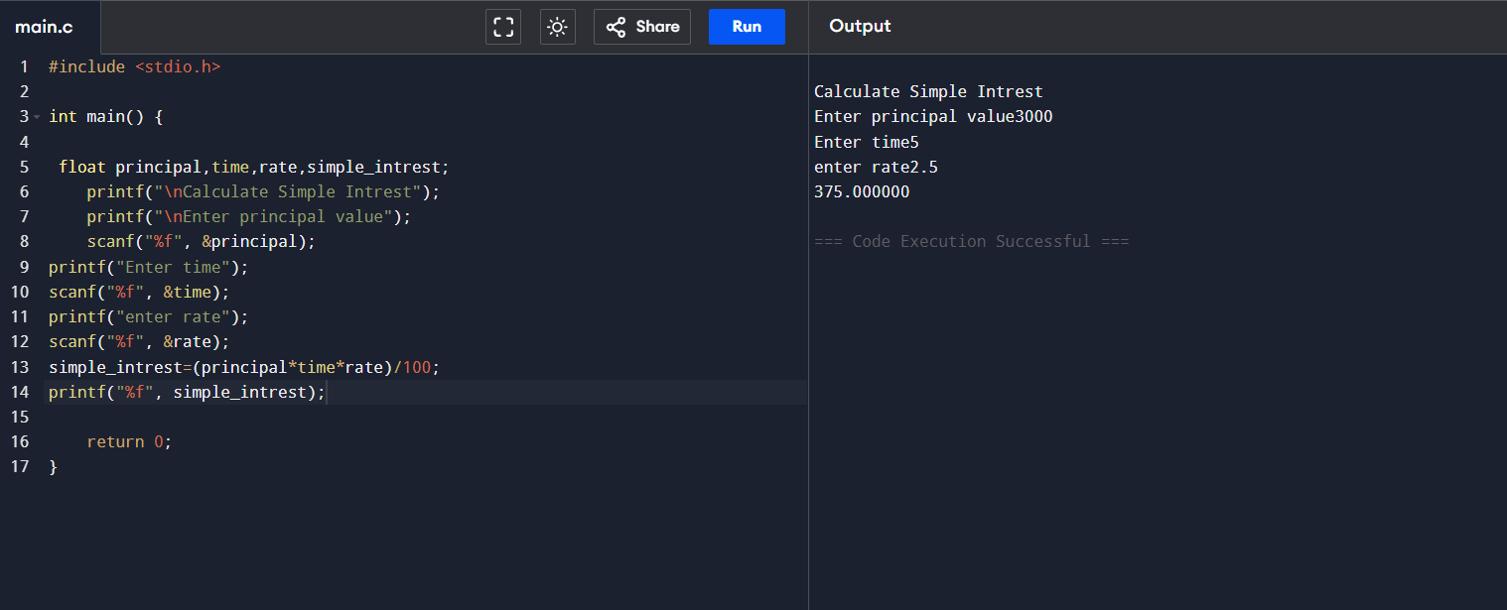

Q5.Area of circle?

Q6.Celsius to Fahrenheit?

Q7.Fahrenheit to Celsius?

Q8.Area and perimeter of rectangle?

Q9.Swapping of two number?

